Sprint 3 vs Sprint 4 Change Summary
Note: “Removed / no longer repeated / scope exclusions” distinguishes confirmed exclusions from Sprint 3 functions that remain in place but are not repeated in this incremental Sprint 4 document.
Comparison item | Added or modified | Removed, not repeated, or out of scope
Data-model update | Retained the Sprint 3 core entities and updated the descriptions of friend recommendation results and AI personalisation data so they can support backend ordering, cached results, and controlled Gemini integration. | Sprint 3 Friend Request, Friendship, Profile visibility, and event-social entities are not removed. Some Sprint 4 backend operational records are documented in the technical data notes rather than being added to the core Mini ERD.

Sprint 4 Mini ERD - Backend, AI, and Recommendation Data Update

Updated ERD deliverable for the Sprint 4 backend, AI, and recommendation-ranking data increment.
Model Boundary: This mini ERD adds Sprint 3 social discovery, Profile visibility, Friend Request, Friendship, Friend Page filter support, Event interested social layer, and AI handoff artifacts without changing frozen Sprint 2 Check-in location boundaries.

Updated Sprint 4 ERD Diagram
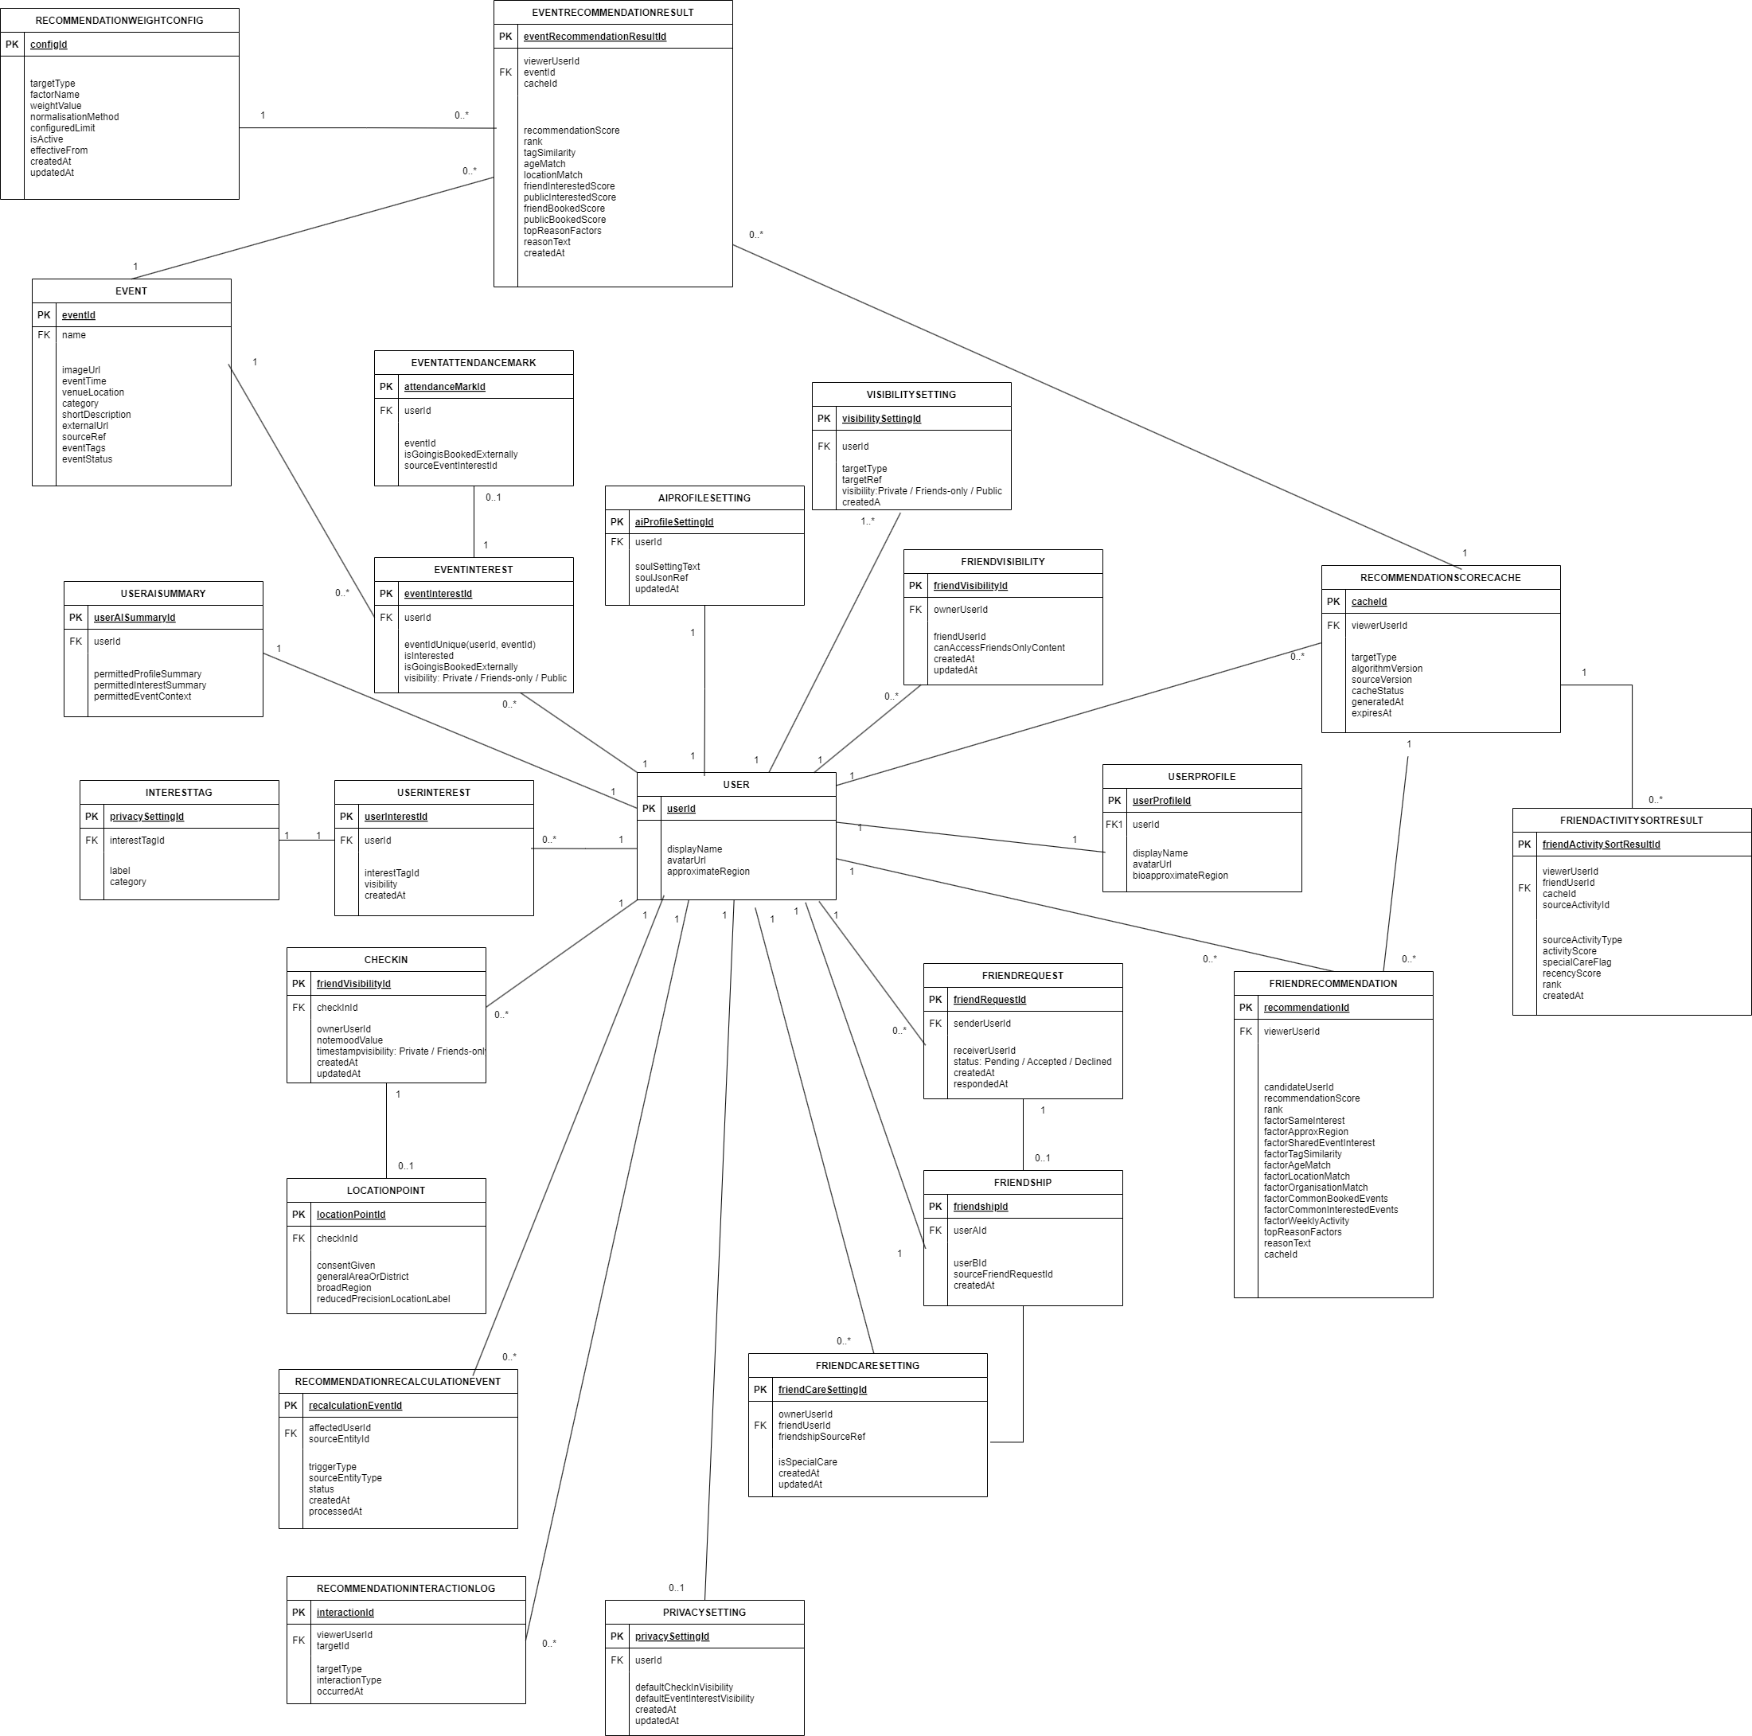

Entity Summary
Entity | Purpose | PK | Main Fields | Relationship | Notes
User | Existing external user reference for Sprint 3 social flows. | userId | displayName; avatarUrl; approximateRegion | Profile, friendship, recommendations, Check-in, EventInterest | No full account-management module.
UserProfile | Existing Profile content shown through permission-based viewer states. | userProfileId | userId FK unique; displayName; avatarUrl; bio; approximateRegion; createdAt; updatedAt | User 1:1 UserProfile | Public Profile is not a separate module.
VisibilitySetting | Stores visibility for supported Profile information. | visibilitySettingId | userId FK; targetType; targetRef; visibility; createdAt; updatedAt | User 1:many VisibilitySetting | Allowed visibility: Private, Friends-only, Public. No separate per-event selector.
InterestTag | Reusable interest label for matching and Profile display. | interestTagId | label; category | User many-to-many InterestTag through UserInterest | Used only when permitted.
UserInterest | Join table between User and InterestTag. | userInterestId | userId FK; interestTagId FK; visibility; createdAt | Unique(userId, interestTagId) | Can support same-interest recommendation.
FriendRequest | Request sent from recommendation card or existing Profile. | friendRequestId | senderUserId FK; receiverUserId FK; status; createdAt; respondedAt | User 1:many as sender and as receiver | Accept establishes friendship; decline does not create block/report.
Friendship | Established friendship after accepted request. | friendshipId | userAId FK; userBId FK; sourceFriendRequestId; createdAt | User many-to-many User through Friendship | No delete friend/block/report workflow.
FriendVisibility | Access check for Friends-only information under established friendship. | friendVisibilityId | ownerUserId FK; friendUserId FK; canAccessFriendsOnlyContent; createdAt; updatedAt | Works with Friendship and content visibility. | Does not duplicate content visibility.
Event | Event details from approved source/mock data. | eventId | name; imageUrl; eventTime; venueLocation; category; shortDescription; externalUrl; sourceRef | Event 1:many EventInterest | No booking/payment processing.
EventInterest | One user's manual interest state for one Event. | eventInterestId | userId FK; eventId FK; isInterested; isGoing; isBookedExternally; visibility; createdAt; updatedAt | Unique(userId, eventId) | Visibility supports Private/Friends-only/Public for Sprint 3 interested-event display.
EventAttendanceMark | Prototype read model for going/booked externally activity filters. | eventAttendanceMarkId | userId FK; eventId FK; isGoing; isBookedExternally; sourceEventInterestId; updatedAt | Mirrors EventInterest manual marks. | Does not prove verified booking or attendance.
FriendRecommendationResult | Transient recommendation card result. | recommendationId | viewerUserId; candidateUserId; factorSameInterest; factorApproxRegion; factorSharedEventInterest; reasonText | Uses UserProfile, UserInterest, EventInterest visibility. | Backend score/rank may be stored only for ordering and cache; no raw formula, hidden factor, compatibility score, similarity percentage, or confidence score is displayed to users.
AIProfileSetting | AI Customize handoff artifact for personality/soul setting. | aiProfileSettingId | userId FK unique; soulSettingText; soulJsonRef; updatedAt | User 1:1 AIProfileSetting | Handoff artifact may feed the Sprint 4 backend Gemini adapter; no direct client-side Gemini call or permission-changing AI behaviour.
UserAISummary | Permitted user summary for AI input contract. | userAISummaryId | userId FK unique; permittedProfileSummary; permittedInterestSummary; permittedEventContext; updatedAt | User 1:1 UserAISummary | Contains only user-allowed data.
CheckIn | Frozen Sprint 2 Check-in record with Sprint 3 weather display nearby. | checkInId | ownerUserId; note; moodValue; timestamp; visibility; createdAt; updatedAt | User 1:many CheckIn | Weather display does not alter CheckIn fields.

Key Relationship Rules
- User 1:1 UserProfile.
- User many-to-many InterestTag through UserInterest.
- User 1:many FriendRequest as sender and 1:many FriendRequest as receiver.
- User many-to-many User through Friendship after request acceptance.
- User many-to-many Event through EventInterest.
- EventAttendanceMark mirrors Going and Booked externally marks for prototype filtering and does not verify attendance.
- User 1:many VisibilitySetting; User 1:1 AIProfileSetting; User 1:1 UserAISummary.

Phase Review
- Covers every relationship listed in the Sprint 3 division document.
- Keeps CheckIn, LocationPoint, moodValue, PrivacySetting, and Sprint 2 location boundary stable.
- Does not add live GPS, exact address, booking/payment verification, block/report/delete friend, or chat/group behavior. Sprint 4 adds Gemini only through the protected backend and does not permit direct client-side AI access or unconstrained AI behaviour.
- Keeps CheckIn, LocationPoint, moodValue, PrivacySetting, and Sprint 2 location boundary stable.

Sprint 4 Incremental Update
English: Sprint 4 is a technical increment for AI integration, backend architecture, and implementation decisions. It must be read together with the frozen Sprint 2 and Sprint 3 requirements, and it does not redesign the existing user stories.

Sprint 4 ERD Image Update
English: The ERD image in this document has been replaced with the updated Sprint 4 diagram supplied by the team. The diagram keeps the frozen Sprint 2/Sprint 3 privacy and visibility decisions while adding the Sprint 4 recommendation/ranking data classes.

